



**Module Code & Module Title**

**CS5053NI/CC5068NI– Cloud Computing & IoT**

**<<Project Title Here>>**

**Assessment Type**

**10% Proposal Report**

**Semester**

**2023 Spring/Autumn**

**Group members**

|  |  |
| --- | --- |
| **London Met ID** | **Student Name** |
|  |  |
|  |  |
|  |  |
|  |  |
|  |  |

**Assignment Due Date:**

**Assignment Submission Date:**

**Submitted to: Mr. Sugat Man Shakya**

**Word Count:**

*I confirm that I understand my coursework needs to be submitted online via Google Classroom under the relevant module page before the deadline in order for my assignment to be accepted and marked. I am fully aware that late submissions will be treated as non-submission and a mark of zero will be awarded.*

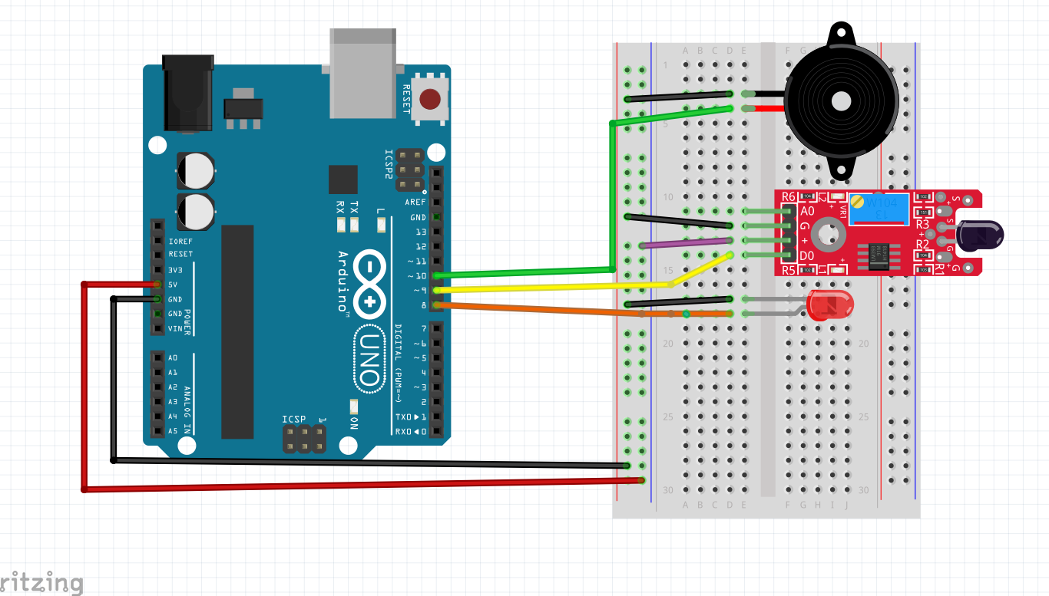

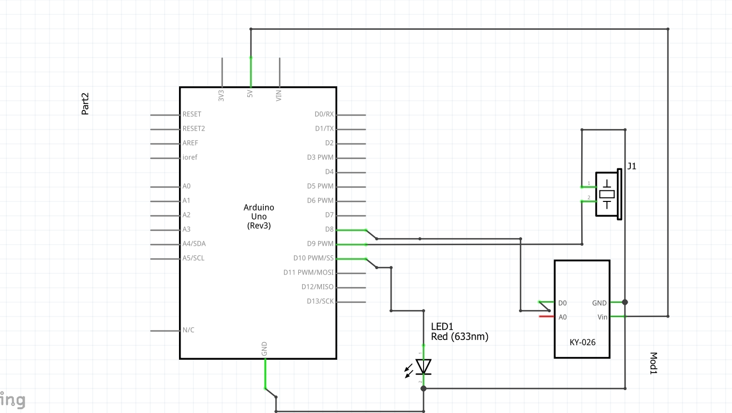

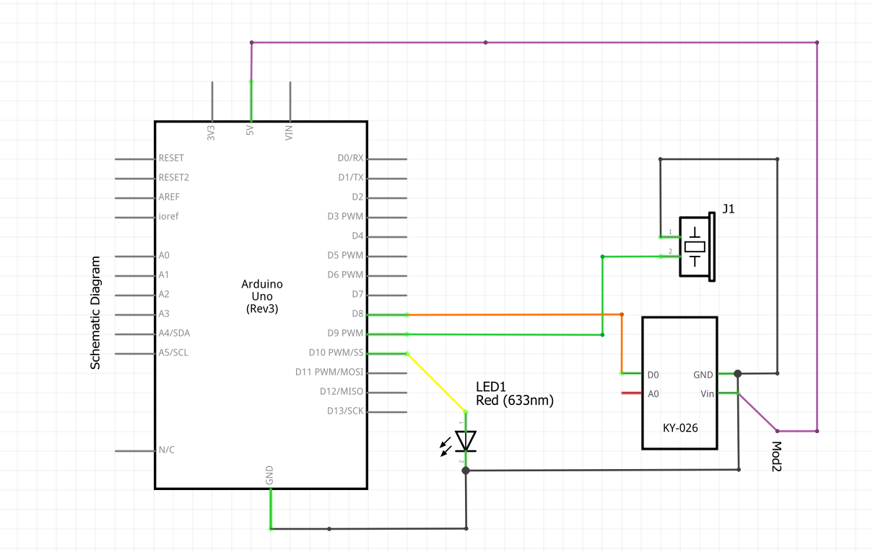

Figure :Schematic

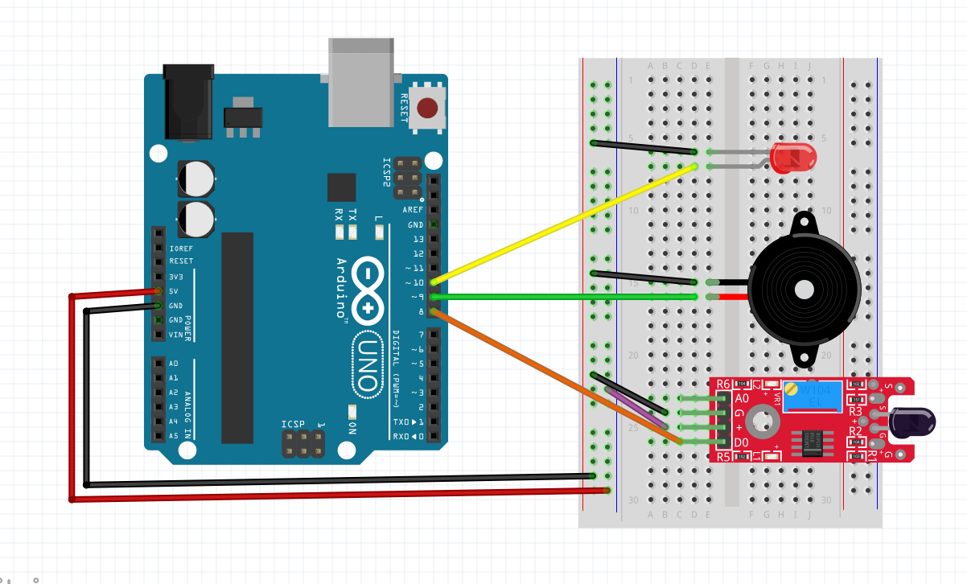

Figure : Circuit diagram

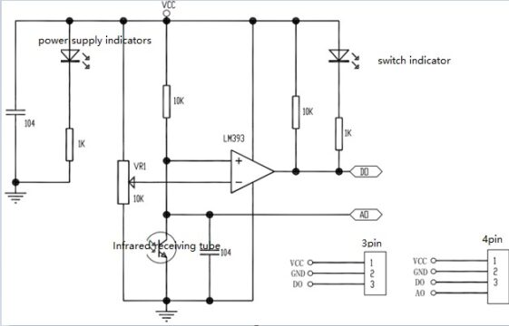

It’s a circuit diagram for a flame sensor module with an LM393 comparator.

The LM393 is a low-power integrated circuit that’s commonly used in various sensor applications. In this particular circuit, it acts as a voltage comparator for the flame sensor.

Here’s a breakdown of the circuit:

* Power Supply:
  + VCC: This is the positive supply voltage, typically 12V.
  + GND: This is the ground connection.
* Flame Sensor:
  + Infrared receiving tube: This is the flame sensor itself. It detects the infrared radiation emitted by flames. When a flame is present, the sensor’s resistance decreases.
  + 104 resistors: These resistors set the current through the infrared receiving tube.
* Comparator (LM393):
  + 1K resistors: These resistors set the reference voltage for the comparator.
  + VR1: This is a variable resistor (potentiometer) that allows you to adjust the sensitivity of the flame sensor.
  + DO, AD: These are the output pins of the comparator. DO goes high when a flame is detected, and AD goes low.
* Power Supply Indicators:
  + LEDs: These LEDs light up when power is supplied to the circuit.
  + 10K resistors: These resistors limit the current to the LEDs.

Overall, the circuit works like this:

1. When a flame is present, the resistance of the infrared receiving tube decreases.
2. This causes the voltage at the non-inverting input (DO) of the comparator to rise.
3. If the voltage at DO is higher than the reference voltage set by VR1, the output of the comparator (AD) goes high.
4. This can be used to trigger an alarm or other safety device.

The power supply indicators simply show that the circuit is powered on.

Here are some additional things to note:

* The specific values of the components may vary depending on the specific flame sensor module you are using.
* The sensitivity of the circuit can be adjusted by turning VR1.
* This circuit is not intended for use in safety-critical applications.

System Architecture

